Citizenship, Economics and Society
(Secondary 1-3)
Support Resources
Secondary 2

Module 2.3:
Public Finance
of Hong Kong

Personal, Social and Humanities Education Section
Curriculum Development Institute
Education Bureau
Introduction

- The “Citizenship, Economics and Society (Secondary1-3) Support Resources” covers the essential learning contents of Strands 1, 5 and 6 in the Personal, Social and Humanities Education Key Learning Area. It is designed to support the implementation of the Citizenship, Economics and Society curriculum.
- The support resources provide diversified learning activities to help
students acquire knowledge and understand concepts, develop skills
and nurture positive values and attitudes. In addition, they offer
teaching guidelines and suggestions on learning and teaching activities for teachers’ reference. Further, they provide reading materials to enhance students’ interest in reading.
- “Module 2.3: Public Finance of Hong Kong” for Secondary 2 was developed by the Personal, Social and Humanities Education Section, Curriculum Development Institute of the Education Bureau. Part of the contents of this resource is based on the learning and teaching materials developed by Hong Kong Effective Teaching Association and the Business School of the Chinese University of Hong Kong, commissioned by the PSHE Section in 2014 and 2019 respectively.

Module 2.3: Public Finance of Hong Kong

Contents

 | Pages
Introduction to the Resource | 4
Teaching Design
Lesson 1 and Lesson 2: Major items of government revenue and expenditure and characteristics of the taxation system in Hong Kong | 5
Lesson 3 to Lesson 6: Factors that the government will consider in managing public finance as well as the constraints it faces | 8
Lesson 7 and Lesson 8: How public finance is related to the citizens | 13
Learning and Teaching Activities
Lead-in Activity 1: Why should we study public finance? | 16
Worksheet 1: The sources of government revenue in Hong Kong | 18
Worksheet 2: What are government expenditure items in Hong Kong? | 20
Worksheet 3: Characteristics of the taxation system in Hong Kong (1) | 24
Worksheet 4: Characteristics of the taxation system in Hong Kong (2) | 26
Lead-in Activity 2: How to prepare budget? | 31
Worksheet 5: Factors that the government will consider in managing public finance as well as the constraints it faces | 34
Worksheet 6: Case Study - Anti-epidemic measures | 45
Extended Worksheet: The Unemployed Chef Wong | 50
Worksheet 7: Our responsibilities and rights | 51
Lead-in Activity 3: “Do you know our needs, Mr. Financial Secretary?” | 55
Worksheet 8: Please listen to us, Mr Financial Secretary. | 56
Reference | 57

Introduction to the Resource:
The use of public funds is closely related to our daily lives and will directly affect people’s livelihood and the development of the society. This resource aims at equipping students with foundation knowledge of public finance, including the major items of government revenue and expenditure, objectives of public finance, the characteristics of the taxation system in Hong Kong as well as factors that the government will consider in managing public finance and the constraints it faces. Supplemented with a case study, students can further understand and investigate issues related to public finance in society, and learn to make objective and evidence-based comments. Through understanding the public finance of Hong Kong, students can cultivate the attitudes of caring about social affairs, as well as attempt to analyse the public finance policies of the government from the perspective of the overall well-being of society

Prior Knowledge:
At the primary level, students have learned to understand their community and develop a concern for community affairs. They have also understood the rights and responsibilities of individuals. Relevant learning contents of General Studies include “to recognise that economic decisions of society can affect our lives as well as the environment”, “to understand our rights and responsibilities as consumers of goods and services and in using community facilities” and “to reflect on the balance between one’s rights and responsibilities”. At the junior secondary level, students have learned to use money rationally and responsibly from an individual perspective in Module 1.3 “Financial Education”.

Learning Points:
- Major items of government revenue and expenditure and objectives of public finance
- Hong Kong’s simple and low tax system
- Differences in taxes and tax rates between Hong Kong, the Mainland and other developed countries
- Factors that the government will consider in managing public finance as well as the constraints it faces, including the principles underlying the government’s management of public finance enshrined in the Basic Law and policy directions of the government
- The social and economic impact of government revenue and expenditure
- Citizens have the responsibility of paying taxes and the right to social welfare in accordance with law
- Caring about social affairs and making an attempt to analyse government’s public finance policies from the perspective of the overall well-being of society

Suggested Number of Lessons:
- 8 lessons (40 minutes each)
Teaching Design
Topic: | Public Finance of Hong Kong
Duration: | 8 lessons
Learning Objectives: | - understand the major items of government revenue and expenditure;  - recognise the simple and low tax system of Hong Kong;  - recognise the objectives of public finance;  - understand the factors to be considered by the government when managing public finance as well as the constraints it faces;  - understand the impacts of government revenue and expenditure on society and the economy;  - identify the major sources of government revenue and items of expenditure from relevant information sources and analyse data and graphs related to public finance;  - understand that residents have the obligation to pay taxes and the right to social welfare in accordance with law; and  - develop a concern for social affairs through understanding public finance of Hong Kong, as well as analyse the government’s public finance policies from the perspective of the overall well-being of society.
Lesson 1 and Lesson 2 (Major items of government revenue and expenditure and characteristics of the taxation system in Hong Kong)
Lesson 1
 |  | Suggested lesson time
Enquiry Process: | - Set: The teacher briefly introduces the contents of these eight lessons and uses the “Lead-in Activity 1: Why should we study public finance?” to help students understand that public finance is closely related to our daily lives. | 10 minutes
 | - Interactive teaching:  - With the aid of some examples, the teacher makes use of Source 1 of Worksheet 1 to help students understand the major items of government revenue and their respective proportions in the total revenue. The teacher asks students to work in pairs to answer Questions 1-3 within 10 minutes, and then invites some students to share their answers. Following up on students’ answers, the teacher gives further explanation. | 25 minutes
 | - Conclusion:  - The teacher concludes the lesson and briefly explains the requirements of the homework and Worksheet 2. | 5 minutes
Homework: | Students watch the two videos “Government Revenue” and “Government Expenditure” and review the key learning points in Lesson 1. Students preview the major government expenditure and complete Worksheet 2.
Extended activities: | Students collect information and analyse the trend of changes in government revenue in Hong Kong over the past two decades and study the relationship between government revenue and overall economic performance based on the information provided on the website.
Learning and Teaching Resources: | Lead-in Activity 1; Worksheets 1-2;  Video “Government Revenue” (Duration: 3:06 (10:02-13:06))  Video “Government Expenditure” (Duration: 3:22 (6:37-9:56))

Lesson 2
 |  | Suggested lesson time
Enquiry Process: | - Set: The teacher briefly reviews the key learning points in Lesson 1 and asks students to present their answers in Worksheet 2 and share examples of government expenditure. | 10 minutes
 | - Interactive teaching:  - The teacher revises with students the “Knowledge Content: Public Finance” to consolidate their understanding of the major items of government revenue and expenditure.  - The teacher shows the video “Characteristics of the taxation system in Hong Kong” to introduce the characteristics of the taxation system in Hong Kong. Students work in pairs to discuss and answer Questions 1-3 in Worksheet 3. After students finish the discussion, the teacher invites some students to share their answers. The teacher then explains the answers and the relevant contents.  * Based on students’ interest, ability level and prior knowledge, the teacher may discuss with students the Challenge question “Why might a narrow tax base bring risks to public finance? | 25 minutes
 | - Conclusion:  - The teacher concludes the lesson and consolidates students’ learning by asking them questions about the meaning of public finance, revenue and expenditure of Hong Kong government and characteristics of the taxation system in Hong Kong. | 5 minutes
Homework: | The teacher briefly explains the requirements in Worksheet 4 and asks students to finish it at home. Students read Appendix 1 “Know More: Comparison of the salaries tax rates between Hong Kong and other parts of the world” at home. It helps enrich students’ knowledge of the taxation system of Hong Kong.
Learning and Teaching Resources: | Worksheets 2-4 ; Appendix 1; Video “Characteristics of the taxation system in Hong Kong” (Duration:3:44 (15:22-19:06))

Lesson 3 to Lesson 6 (Factors that the government will consider in managing public finance as well as the constraints it faces)
Lesson 3
 |  | Suggested lesson time
Enquiry Process: | - Set:  - The teacher briefly reviews the key learning points in Lessons 1 and 2 and invites students to share their answers in Worksheet 4. This helps students understand that Hong Kong has a lower tax rate than the Mainland and most other places around the world. | 15 minutes
 | - Direct instruction:  - The teacher uses “Basic Law ABC” to help students understand the provisions of the Basic Law which are related to the taxation system of the HKSAR. The teacher shows the video “Things You Must Know about the Public Finance of Hong Kong” and take the United States as an example to illustrate the characteristic of the simple and low tax system in Hong Kong.  - The teacher revises the “Knowledge Content: Characteristics of the taxation system in Hong Kong” with students to help them review the characteristics of the taxation system in Hong Kong. | 15 minutes
 | - Conclusion:  - The teacher concludes the lesson and makes use of “Lead-in Activity 2: How to prepare the Budget?” to stimulate students to think about what factors they would consider in formulating the Budget if they were the Financial Secretary. Students then share their views and prepare for the next topic. | 10 minutes
Homework: | Students review what they have learned at home and browse the Budget website so as to understand the government’s Budgets in recent years.
Learning and Teaching Resources: | Worksheet 4; Extended worksheet 1; Lead-in Activity 2;  Video “Things You Must Know about the Public Finance of Hong Kong” (Duration:0:40 (16:04-16:44))

Lesson 4
 |  | Suggested Lesson Time
Enquiry Process: | - Set: The teacher introduces three different types of budget, including surplus budget, balanced budget and deficit budget, and then invites students to categorise the types of budget which Budget 2019-20 and Budget 2020-21 belong to. | 5 minutes
 | - Interactive teaching:  - The teacher makes use of Worksheet 5 and asks students to work in pairs to finish Questions 1-3. The teacher then checks the answers with the students. This part helps students understand the overall incomes and expenditures of the government in the past 20 years and the principles that the government adopts in managing its finance.  - Students then continue their discussion, finish Questions 4-5 and then share their answers and views. With the aid of examples, this part enables students to understand and think about the factors affecting government expenditures. | 30 minutes
 | - Conclusion:  - The teacher concludes the lesson and briefly explains the requirements of the homework. | 5 minutes
Homework: | Students think about what can be done by the government in the short term and the long term if it faces a persistent fiscal deficit, and share their views in class in the coming lesson.
Learning and Teaching Resources: | Worksheet 5

Lesson 5
 |  | Suggested Lesson Time
Enquiry Process:  Homework: | - Set:  - The teacher guides students to share their views on what can be done by the government in the short term and long term if it faces a persistent fiscal deficit. | 10 minutes
 | - Interactive teaching:  - The teacher reviews the key learning points in Lessons 1-4 with students by asking them questions. Then the teacher reviews the key messages in the “Knowledge Content: Objectives of public finance” to help students consolidate their learning, including the three objectives of public finance (re-distributing income, promoting long-term economic development, responding to social needs) and factors affecting government expenditures (the principle of managing public finanance as stipulated in the Basic Law, the amount of government revenues and reserves as well as the policy directions of the government, etc.) Students should also be reminded that government revenues and reserves are limited resources and allocating more resources to one item (e.g. education) means cutting the amount to be allocated to other areas (e.g. medical care). | 15 minutes
 | - Direct instruction and conclusion:  - The teacher uses Appendix 2 “Know More: Approval of the Budget rests with the Legislative Council” to explain to students that the Budget has to be examined and approved by the Legislative Council; whether the Legislative Council can refuse to pass the budget proposed by the government; and the impact of government fiscal policy on economy.  - The teacher concludes the lesson and briefly explains the requirements of homework. | 15 minutes
 | Students read Appendix 2 “Know more: Approval of the Budget rests with the Legislative Council”, Appendix 3 “Know more: Can the Legislative Council refuse to pass a budget proposed by the government?” and Appendix 4 “Know more: What are the economic impacts of the government fiscal policy?”, at home. It helps enrich students’ knowledge of public finance of Hong Kong.
Learning and Teaching Resources: | Appendices 2-4

Lesson 6
 |  | Suggested Lesson Time
Enquiry Process: | - Set:  - The teacher briefly explains to students that Worksheet 6 “Case Study - Anti-epidemic measure” will be used to illustrate that public finance is closely related to the public. | 5 minutes
 | - Interactive teaching:  - The teacher assigns students to read the sources in Worksheet 6 and work in pairs to finish the questions. The sources in the worksheet can help students understand that under special circumstances, or when the economy is facing serious economic downturns, the government will increase its expenditures. At the same time, government revenues will also decrease when facing an economic downturn. This activity provides opportunities for students to think about the principles of prioritising public finance and the reasons behind, for example, which industries or groups of people should be supported first. The teacher then guides students to assess the appropriateness of strategies based on the actual situation.  * The teacher may decide whether to ask students to complete Extended Worksheet 2 “Unemployed Chef Wong” based on their interest, ability level and prior knowledge. | 30 minutes
 | - Conclusion:  - The teacher briefly concludes the key learning points in Lessons 3-6. | 5 minutes
Learning and Teaching Resources: | Worksheet 6; Extended Worksheet 2

Topic: | Our Responsibilities and Rights
Duration: | 2 lessons
Learning Objectives: | - To understand citizens have the responsibility of paying taxes and the right to social welfare in accordance with law  - To care about social affairs and to participate in the development of the society
Prior Knowledge: | Students should understand their rights and responsibilities and be able to reflect on how to strike a balance between rights and responsibilities.
Lesson 7 and Lesson 8 (How public finance is related to the citizens)
Lesson 7
 |  | Suggested Lesson Time
Enquiry Process: | - Set:  - The teacher briefly introduces the contents of these two lessons. | 5 minutes
 | - Interactive teaching:  - Use the background information of the three cases provided in Worksheet 7 to facilitate students’ understanding of the taxes those people in the cases are liable to pay and the kinds of government services they can enjoy.  - The teacher asks students to complete Questions 1-3 and check the answers with them. Then students discuss in pairs and complete Questions 4-5. The teacher asks students to reflect on whether they agree that “people who earn higher income should pay more tax”, and think about what the government can do to alleviate the problem of disparity between the rich and the poor.  - The teacher should also remind students that rights go with responsibilities and citizens have the responsibility to pay taxes. | 30 minutes
 | - Students’ reflection and conclusion:  - The teacher guides students to think about their and their family members’ responsibilities with regard to public finance. Moreover, the teachers may ask students to share how they can contribute to society now and in the future.  - The teacher concludes the lesson and briefly explains the requirements of the homework. | 5 minutes
Homework: | Students revise the “Knowledge Content: Relationship between the government and Hong Kong citizens in public finance” and try to interview two friends or family members to understand what they would like to tell the Financial Secretary and the reasons behind it. They should also evaluate whether the relevant suggestions are feasible and should be implemented, and then decide what they want to express to the Financial Secretary.
Learning and Teaching Resources: | Worksheet 7

Lesson 8
 |  | Suggested Lesson Time
Enquiry Process: | - Set:  - The teacher uses the two phenomena in ‘Lead-in Activity 3: “Do you know our needs, Mr. Financial Secretary?”’ as an introduction to guide students to think about which part of public expenditures can be increased to respond to the two problems. | 5 minutes
 | - Interactive teaching:  - The teacher makes use of Worksheet 8 and asks students to form groups of four to share their results of interviews, through which students can understand that different people will have different views on public finance.  The teacher then asks different groups to share the policies that they consider feasible and worth supporting. After the sharing of each individual group, other groups may ask them questions so as to understand more about the importance and feasibility of different policies. | 25 minutes
 | - Conclusion and students’ reflection:  - The teacher concludes the lesson and, through questioning or providing guidance, reminds students that in order to become rational and responsible citizens, they should develop the ability to analyse the arguments of different stakeholders on government’s revenue and expenditure policies; that upon understanding the needs of different people in society, they should use proper channels (such as participating in the Government’s consultation exercise) to express their views on the government Budget; and that they should attempt to analyse the government’s public finance policies from the perspective of the overall well-being of society. | 10 minutes
Learning and Teaching Resources: | Lead-in Activity 3; Worksheet 8

Module 2.3：Public Finance of Hong Kong
(Lessons 1 and 2)
Learning and Teaching Materials

Lead-in Activity 1: Why should we study public finance?
In simple words, public finance is the financing of government. This includes government revenue and government expenditure.

What do the following cases have to do with the public finance of Hong Kong?
I have diabetes and I’m on long-term medication. When I go to the public hospital for consultation and medicines, I only pay $95 each time. It’s much cheaper than a private clinic.

I’m the “King of employees”. Each year, I earn more than $100 million and pay over $10 million as salaries tax!

The government has implemented 15-year free education My new born baby can enjoy free education till his graduation from secondary school.

My company pays about 16% of its profits to the government every year as profits tax. The amount is quite large. But the tax rate is not very high compared with other countries.
I bought my own flat this year. Other than the property price, I also needed to pay more than $300,000 for stamp duty to the Inland Revenue Department.

Think about it: What does public finance have to do with me?
- Which of the items above are related to government revenue? Which ones are related to government expenditure?
- Can you guess what is the main source of government revenue in Hong Kong? And what are the major government expenditure items?
- Have you used any of the public facilities or services provided by the government? Do you know the cost of providing those facilities or services?

Worksheet 1: What are the sources of government revenue in Hong Kong?

Source 1: Major items of government revenue (estimated figures) and their respective percentages of total revenue (2022-2023)

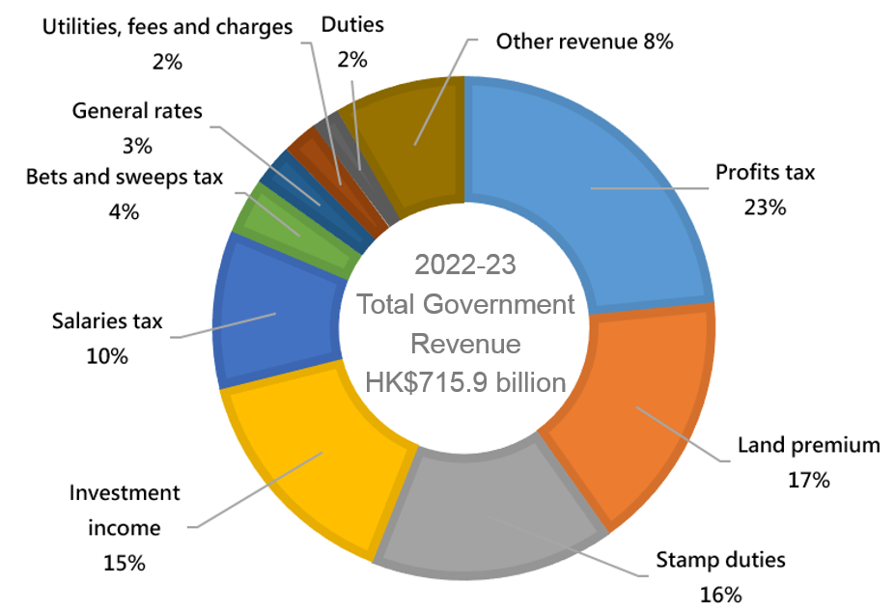
Examples of other revenue:
- Air passenger departure tax  - Fines, forfeitures and penalties | - Motor vehicle taxes  - Property tax
Source: The 2022-23 Budget https://www.budget.gov.hk/2022/eng/io.html

(Note: Generally speaking,
Profits tax is a tax that Hong Kong companies need to pay when they make profits while operating their business.
Stamp duty is a tax imposed on transaction of real estate, leases and share transfers.
General rates are taxes levied on real estate properties. Both the landlord and the user of the property are responsible for paying rates. For leased properties, the actual situation depends on the terms of the lease signed by both the landlord and the tenant.)

Answer the following questions based on the information on the previous page.
- Classify different types of government revenue (excluding other revenue).
Tax Revenue | Non-tax Revenue
Profits tax  Stamp duties  Salaries tax  Bets and sweeps tax (betting duty)  General rates  Duties | Land premium  Investment income  Utilities, fees and charges

- List the three most important sources of government revenue in 2022-2023-.
Rank | Item of revenue | Percentage of total revenue
1st | Profits tax | 23%
2nd | Land premium | 17%
3rd | Stamp duties | 16%
4th | Investment income | 15%
5th | Salaries tax | 10%

- Based on Question 2, which social strata are the main revenue sources of the Hong Kong government?
The main sources of revenue for the Hong Kong government are profits tax
paid by the business sector, land premium from land developers
(and landlords of properties), stamp duties from share investors,
buyers and sellers of properties and salaries tax from employed persons

Worksheet 2: What are the government expenditure items in Hong Kong?
Source 1: Estimated government expenditure in 2022-23 (by policy area group)
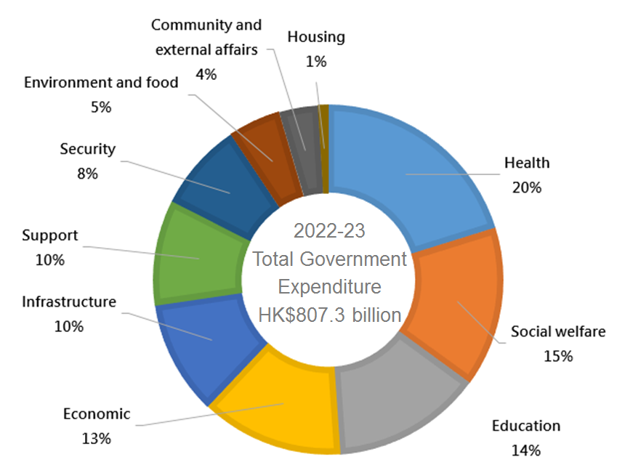
Source: The 2022-23 Budget https://www.budget.gov.hk/2022/eng/io.html

Based on the above information and complete the following table.
Ranking of the expenditure item | Policy Area Group | Percentage of total expenditure
1st | Health | 20%
2nd | Social welfare | 15%
3rd | Education | 14%
Extended Learning:
Visit the 2022-23 Budget webpage, and give some examples for the usage of the government expenditure in the policy area groups mentioned above.

Public Finance
In simple words, public finance refers to the financing of government. This includes government revenue and government expenditure. Public money mainly comes from taxpayers. Government expenditure has a great influence on society, the economy and people’s livelihood. Therefore, the government must manage its finance prudently and use its revenue reasonably, so as to promote social development and improve people's lives.
Values education: Remind students that while most public services are low-cost or even free of charge, the related expenses are actually borne by taxpayers. So everyone should cherish and make good use of public facilities and services.

Government revenue
Revenue of Hong Kong Government
Government revenue includes tax and non-tax revenue. Using the estimated figures of 2022-23 as an example, we can see that government revenue mainly relies on taxation, which accounts for around 60% of total government revenue.

Major taxes in Hong Kong include:
- Profits tax is payable on profits made by a Hong Kong company during business operation.
- Salaries tax is levied on employment income and pensions.
- Stamp duty is payable on real estate transfer/leasing or securities trading.
- General rates are levied on a property. Both the owner and the occupier are liable for rates. For leased property, it depends on the terms of agreement between the owner and the tenant.

Non-tax revenue of the Hong Kong Government includes:
- Land premium: The income obtained by the government from selling land use rights. This is one of the main sources of revenue for the Hong Kong Government.
- Investment income: It includes the return on the fiscal reserves placed with the Exchange Fund.
- Utilities, fees and charges: Charges collected by the government on some public services, such as hire/admission charges of leisure facilities provided by the government, consultation fees in public hospitals, tourist visa fees, as well as various license fees and fines.
Expenditure of Hong Kong Government
Classified by the policy area group, government expenditure can be divided into the categories of education, social welfare, health, infrastructure, support, security, housing, economic, environment and food, as well as community and external affairs. Using the estimated figures in 2022-23 as an example, health accounted for the highest proportion or 20% of total government expenditure.

Major expenditure items of Hong Kong Government
Policy area group | Percentage of total expenditure in 2022-23  (estimated figures) | Example
Health | 20% | Operation of public hospitals and clinics
Social welfare | 15% | Provision of Disability Allowance, Old Age Allowance and Comprehensive Social Security Assistance (CSSA)
Education | 14% | Provision of 15-year free education and other education services
Economic | 13% | Monitoring of the financial system; promotion of tourism and the local economy
Infrastructure | 10% | Construction of transport facilities and supply of fresh water
Support | 10% | Management of civil servants and constitutional affairs
Security | 8% | Maintenance of law and order, immigration security and control
Environment and food | 5% | Maintenance of environmental hygiene and monitoring of food safety
Community and external affairs | 4% | Provision of recreational and cultural facilities and activities; maintaining community and regional relations
Housing | 1% | Construction of public housing

Online Learning
- Students may watch the following videos for revision of the concepts:
Government Expenditure (Duration: 3:22 (6:37-9:56))
https://emm.edcity.hk/media/Things+You+Must+Know+about+the+Public+Finance+of+Hong+Kong/0_6q04b9fm?st=397&ed=599
Source: Educational Multi-media (2017): Things You Must Know about the Public Finance of Hong Kong

Government Revenue (Duration: 3:06 (10:02-13:06))
https://emm.edcity.hk/media/Things+You+Must+Know+about+the+Public+Finance+of+Hong+Kong/0_6q04b9fm?st=600&ed=786
Source: Educational Multi-media (2017): Things You Must Know about the Public Finance of Hong Kong

- Students may visit the following websites to get more information about public finance of Hong Kong:
- The Treasury Branch, Financial Services and the Treasury Bureau:
https://www.fstb.gov.hk/tb/en/public-finance.htm
- Census and Statistics Department ── Government revenue (General Revenue Account and the Funds)
https://www.censtatd.gov.hk/en/web_table.html?id=193
- Census and Statistics Department ── Hong Kong in Figures (the latest figures)：
Government Accounts and Finance
- Government revenue and expenditure
- Public expenditure by policy area group
https://www.censtatd.gov.hk/en/EIndexbySubject.html?scode=460&pcode=B1010006
Teaching tips: Teachers may ask students to study the information provided in the websites and analyze the trend of changes in government revenue over the past 20 years as well as the relationship between the government revenue and the economic performance as a whole.
Worksheet 3: Characteristics of the taxation system in Hong Kong (1)
It is often said that Hong Kong’s taxation system is attractive to a lot of foreign investors. Before we compare taxation systems in different places, let’s take a look at the characteristics of Hong Kong’s taxation system
Characteristics of the taxation system in Hong Kong (Duration: 3:44 (15:22-19:06))
https://emm.edcity.hk/media/Things+You+Must+Know+about+the+Public+Finance+of+Hong+Kong/0_6q04b9fm?st=922&ed=1146
Source: Educational Multi-media (2017): Things You Must Know about the Public Finance of Hong Kong

Watch the above video and answer the questions:
- According to the video, point out the characteristics of Hong Kong’s tax policy.
Hong Kong practises a simple and low tax system, with fewer taxes than other
developed countries.

- As far as the taxation system is concerned, why do you think Hong Kong is attractive to overseas investors?
The tax rates are low in Hong Kong. Companies can retain more earnings after
paying the profits tax. This provides incentive for companies to invest in Hong
Kong.

- What does a narrow tax base mean? Based on the video, explain why Hong Kong faces the problem of a narrow tax base.
(Challenge question: Why might a narrow tax base bring risks to public finance?)

A narrow tax base means the government relies heavily on a small number of
taxpayers to pay one or two types of taxes as the source of revenue.
Taxes in Hong Kong are paid only by a small number of people and companies.
In the 2014-15 tax year, for example, Hong Kong had a working population of
3.77 million. But only about 48% or 1.78 million people needed to pay salaries
tax. The top 5% taxpayers (about 90,000 people) contributed 63% of the revenue
from salaries tax. Besides, only 9% of the registered companies in Hong Kong
paid profits tax. And the top 5% taxpaying corporations (about 5,000
companies) contributed 86% of the revenue from profits tax.
(Challenge question) If the tax base is narrow, when there is an economic
recession, the tax revenue is likely to be greatly reduced, which would weaken
the government’s ability to cover public expenditure.

Module 2.3：Public Finance of Hong Kong
(Lessons 3 to 6)
Learning and Teaching Materials

Worksheet 4: Characteristics of the taxation system in Hong Kong (2)
The Basic Law was enacted in accordance with Article 31 and Article 62 of the Constitution of the People's Republic of China. Article 11 of the Basic Law states that “In accordance with Article 31 of the Constitution of the People's Republic of China, the systems and policies practised in the Hong Kong Special Administrative Region, including the social and economic systems, the system for safeguarding the fundamental rights and freedoms of its residents, the executive, legislative and judicial systems, and the relevant policies, shall be based on the provisions of this Law.”
Regarding the taxation system in Hong Kong, Article 108 of the Basic Law states that-

Article 108 of the Basic Law
The Hong Kong Special Administrative Region shall practise an independent taxation system.

The Hong Kong Special Administrative Region shall, taking the low tax policy previously pursued in Hong Kong as reference, enact laws on its own concerning types of taxes, tax rates, tax reductions, allowances and exemptions, and other matters of taxation.

Source 1
The average profits tax rate (corporate tax rate) of the world is 23.8% in 2020
Reference: Website of the KPMG Global Tax Rate Survey, extracted on 12 November 2020.
Based on the above information, discuss with your classmates and answer the following questions.
- According to Source 1, compare the profits tax rates between Hong Kong, the Mainland and other countries in the world.
The profits tax rate in Hong Kong is lower than those on the Mainland and in
most other countries in the world.

- As far as the profits tax rate is concerned, why Hong Kong is more attractive when compared to the Mainland and other countries in the world? Why?
Since Hong Kong has a lower profits tax rate, enterprises can keep more of
their profits. Corporations will have a higher incentive to invest in Hong Kong.

- A low tax policy is good for the economy. Why doesn’t the Basic Law state this as a requirement to maintain the same “low tax” policy, but make it “as reference” only? Pick the reasons from the table and put a “✓” in the appropriate boxes.
✓ | There are a lot of variables in the economy.
 | A long-term low tax policy is not feasible.
✓ | The HKSAR should be flexible in making tax policies.
✓ | No one knows for sure which taxation system is right for the development of the HKSAR.
 | Hong Kong does not have the conditions to implement a low tax policy.

Basic Law ABC
Article 106 of the Basic Law
The Hong Kong Special Administrative Region shall have independent finances.
The Hong Kong Special Administrative Region shall use its financial revenues exclusively for its own purposes, and they shall not be handed over to the Central People’s Government.
The Central People’s Government shall not levy taxes in the Hong Kong Special Administrative Region.

The types of tax in other countries are generally more than that in Hong Kong. Take United States as an example, taxes are imposed in three levels of government, including the federal government, state governments and local governments.
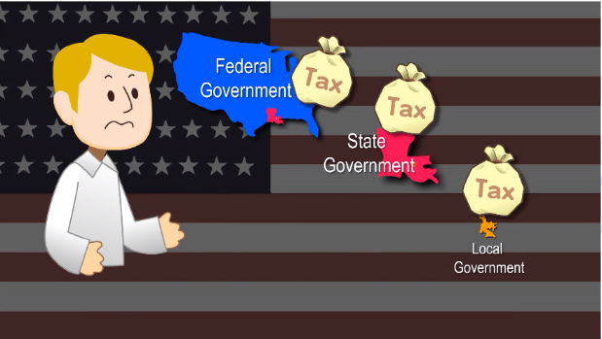

Source: Educational Multi-media: Things You Must Know about the Public Finance of Hong Kong (Duration:0:40 (16:04-16:44))
https://emm.edcity.hk/media/Things+You+Must+Know+about+the+Public+Finance+of+Hong+Kong/0_6q04b9fm?st=922&ed=1146

According to Article 14 of the Basic Law, “The Central People's Government shall be responsible for the defence of the Hong Kong Special Administrative Region…. Expenditure for the garrison shall be borne by the Central People's Government.”

Characteristics of taxation system in Hong Kong
Simple and low tax system
Hong Kong practises a simple and low tax system. It collects fewer taxes at generally lower rates compared with the Mainland and other developed countries.

Reliance on certain sources of revenue
The main sources of fiscal revenue in Hong Kong includes profits tax, land premium, stamp duty and salaries tax. In 2021-22, those four sources accounted for about 70% of the total revenue of the Hong Kong Government. Apparently, the Government relies on those sources of revenue.

Narrow tax base
A narrow tax base means the government relies heavily on a small number of taxpayers to pay one or two types of taxes as the source of revenue. The HKSAR Government collects only a few taxes from a small population of taxpayers. So the tax base is always considered to be too narrow.

Differences between Hong Kong and other developed countries in taxes and tax rates
In Hong Kong,the maximum salaries tax rate is 15%. Hong Kong citizens pay the tax based on their incomes. The salaries tax on the Mainland ranges from 3% to 45%. And it can be as high as 30% to 50% in other developed countries in Europe and the United States. Besides, on the Mainland or in other developed countries, there are many other taxes, which expand the sources of government revenue and enable the government to provide more social welfare for their citizens. In some European countries, they have more financial revenue and spending. Through a larger scale of income reallocation, the governments provide more social welfare to their citizens. They are also known as “welfare states”.

Appendix 1
Know more: Comparison of the salaries tax rates
between Hong Kong and other parts of the world

Source: KPMG. （2020）. Individual income tax rates table. Retrieved from https://home.kpmg/xx/en/home/services/tax/tax-tools-and-resources/tax-rates-online/individual-income-tax-rates-table.html

Lead-in Activity 2: How to prepare budget?
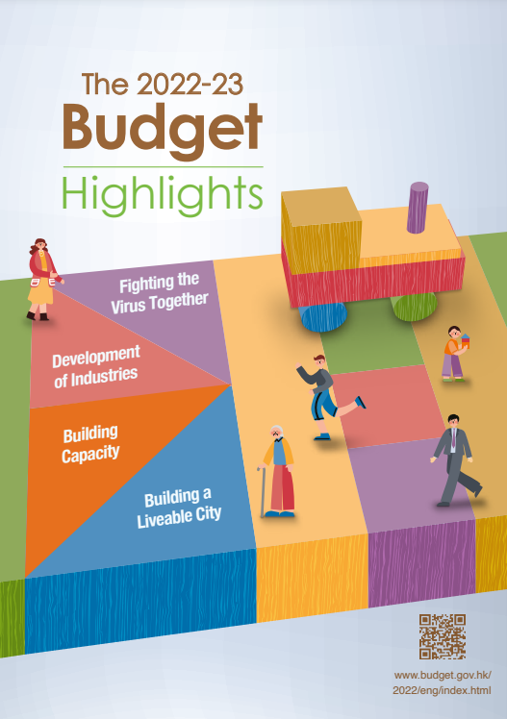
Think about it:
The Financial Secretary prepares the Budget every year. If you were the Financial Secretary, what factors would you consider when preparing the Budget?

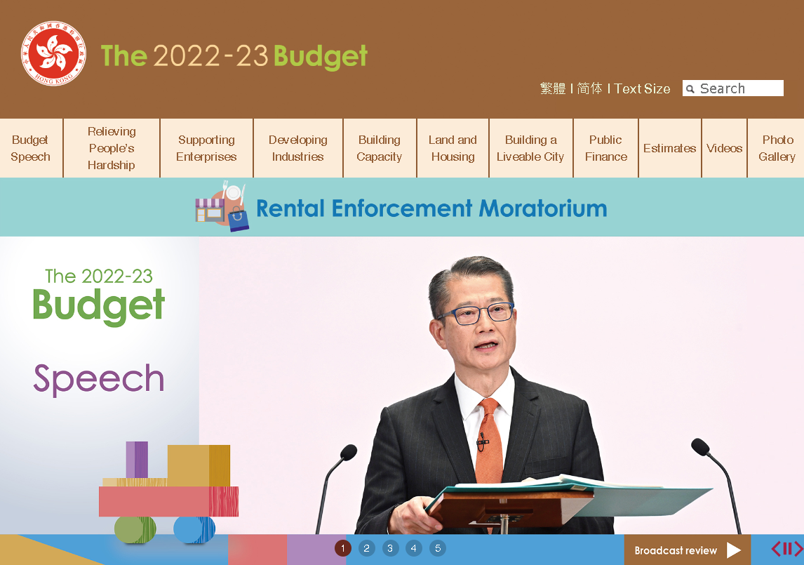
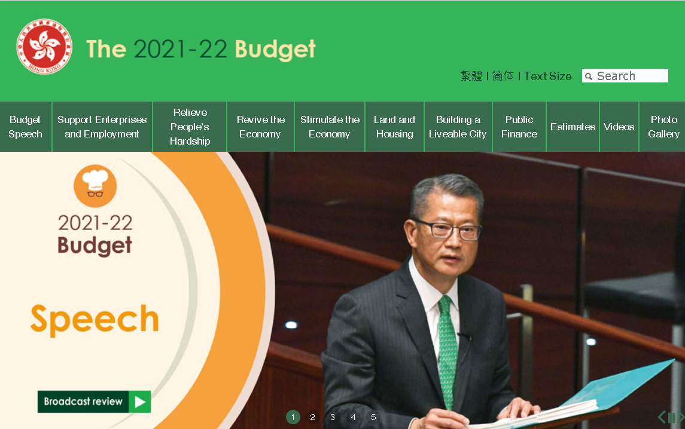

Source: The Budget website
The 2022-23 Budget: https://www.budget.gov.hk/2022/eng/index.html
The 2021-22 Budget: https://www.budget.gov.hk/2021/eng/index.html

Government Budget
The government prepares the Budget every year, which shows the estimated revenue and estimated expenditure of the government in a particular financial year.

Budget can be classified into three different types:
Surplus budget  - Estimated revenue larger than  Estimated expenditure | 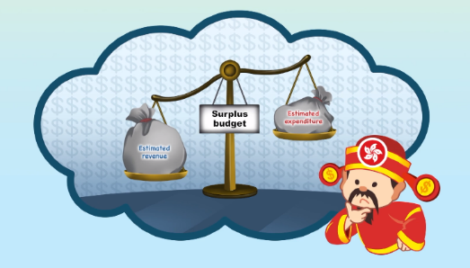
Balanced budget  - Estimated revenue equal to  Estimated expenditure | 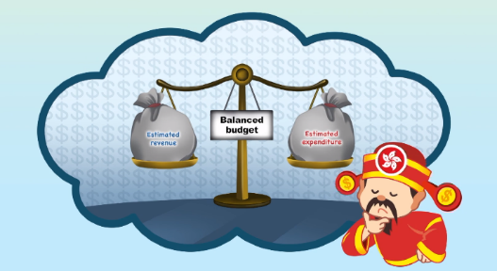
Deficit budget  - Estimated revenue smaller than  Estimated expenditure | 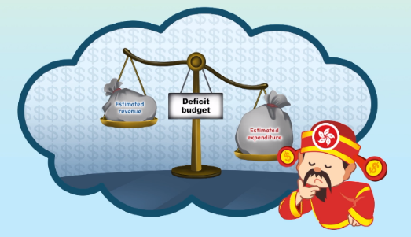

Classify the type of budget that the 2019-20 Budget and the 2020-21 Budget belong to. (*Please delete as appropriate)
- The 2019-20 Budget is a (* surplus / balanced / deficit) budget. 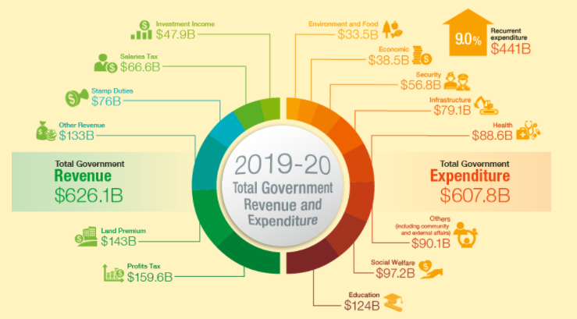
Source: The website of the 2019-20 Budget

- The 2020-21 Budget is a (* surplus / balanced / deficit) budget. 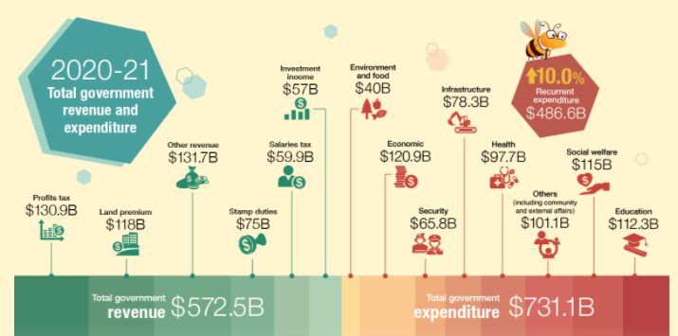
Source: The website of the 2020-21 Budget
Worksheet 5: Factors that the government will consider in managing public finance as well as the constraints it faces

Source 1: Total government revenue and expenditure from 2000 to 2021
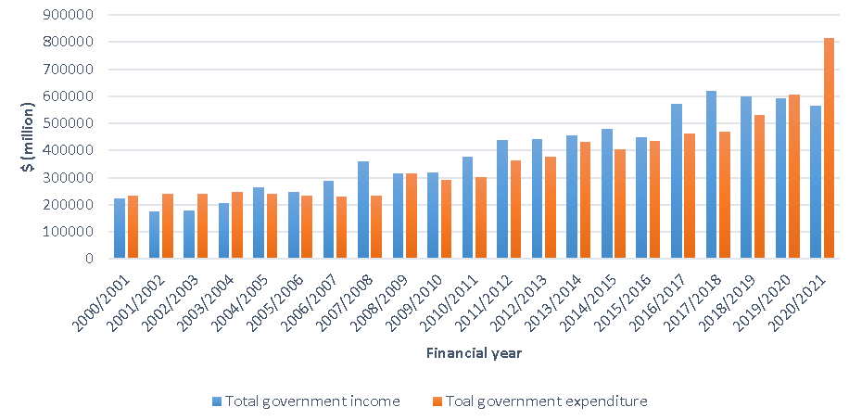
Source: Census and Statistics Department

Source 2: 2017-18 Budget Speech (extract)
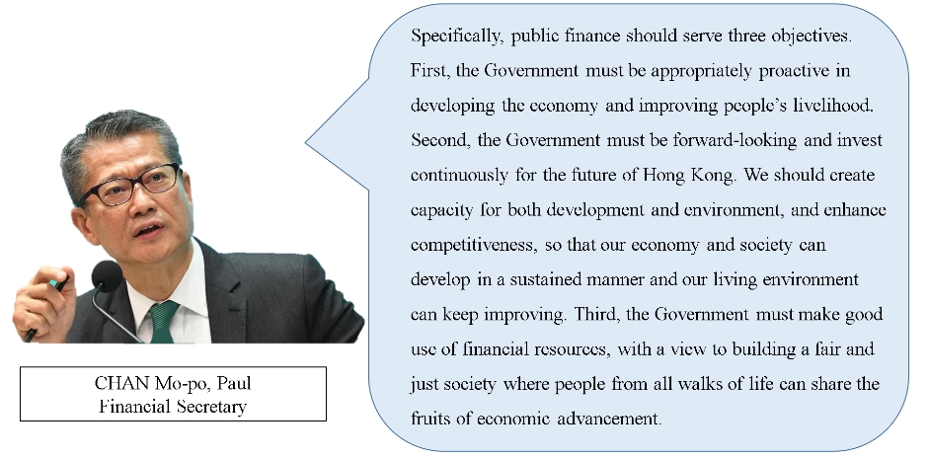
Source: 2017-18 Budget Speech

Source 3: Opinions of different stakeholders on the 2017-18 Budget.
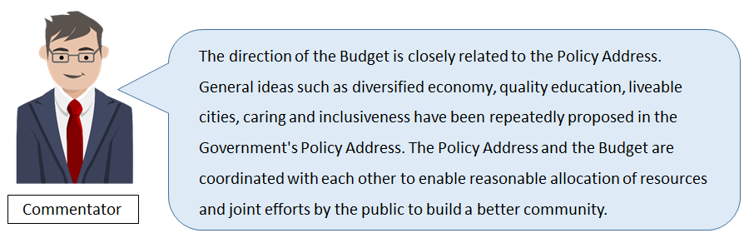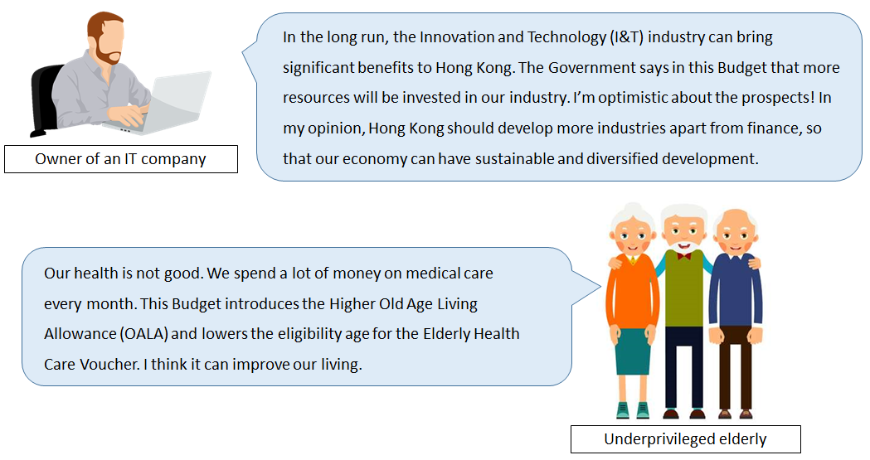

Source 4: Requirements of the Basic Law
Article 107 of the Basic Law

The Hong Kong Special Administrative Region shall follow the principle of keeping expenditure within the limits of revenues in drawing up its budget, and strive to achieve a fiscal balance, avoid deficits and keep the budget commensurate with the growth rate of its gross domestic product.

Answer the following questions based on the sources above.
- Compare the overall revenue and expenditure of the Hong Kong Government during the period 2000 - 2021.
When compared to 2000, government revenue and expenditure have increased
significantly in 2021, though there are ups and downs. When the economic
environment was good, government revenue would rise sharply (such as in
2007-2008 and 2016-2017), resulting in a fiscal surplus. When the economic
environment was poor (such as in 2001-2003, 2020-2021), there was a fiscal
deficit.
(Notes for teachers: It should be noted that these are nominal values. And there
are lagged effects on the government’s fiscal revenue and expenditure. In other
words, the impact on fiscal revenue and expenditure will only appear sometime
after an economic event.)

- What has the fiscal balance of the Hong Kong Government usually been like over the past 20 years? (Hint: Surplus / Deficit / Balanced)
The Hong Kong Government has normally recorded a fiscal surplus over the
past 20 years.

- Based on the above data and trend, what is the Government’s principle of financial management?
The principle of keeping expenditure within the limits of revenues, striving to
achieve a fiscal balance and avoid deficits.

- What are the benefits to the government’s fiscal position by adopting the above financial management principle? Explain briefly with examples.
(Hint: Think about why the government can spend more money than it collects in some years.)
The principle of keeping expenditure within the limits of revenues enables a
sound fiscal position for the Hong Kong Government. It may even increase the
government’s reserves to cope with annual expenditure and possible
emergencies. For example, the government’s fiscal revenue fell sharply in
2001-03, 2008-09 and 2020-21 due to the bursting of the dotcom bubble, the
SARS epidemic, the 2008 global financial crisis and COVID-19 pandemic.
respectively To maintain normal public services, the government needs to have
some reserves to meet its expenditures.

- Based on Sources 2 to 4 and the knowledge acquired, what factors may affect government expenditure? Try to explain two of the factors.
(Hint: We know that government revenue is closely related to the economic environment. How is its expenditure affected by its revenue? What principle does the government follow in financial management? Are there long-term factors besides the current short-term ones?)
- External economic environmental factors: When the economy is in a
recession, government revenues will decrease. It will be necessary to
tighten the spending to achieve a fiscal balance.
- The government’s principle of financial management and requirements of
the Basic Law: The government has always managed public finances
prudently by keeping expenditure within the limits of revenues, maintaining
a low and simple tax system. Article 107 of the Basic Law also states, “The
Hong Kong Special Administrative Region shall follow the principle of
keeping expenditure within the limits of revenues in drawing up its budget,
and strive to achieve a fiscal balance, avoid deficits and keep the budget
commensurate with the growth rate of its gross domestic product.”
- The government’s policy directions: For example, to maintain the long-
term stable development of the economy, the government will invest more
in emerging and / or promising industries, such as the innovation and
technology (I&T) industry in recent years. On the other hand, to cater for
the needs of different groups in the community, such as the elderly and the
underprivileged, the government will introduce financial support measures
based on the economic situation. As a result, related expenses will increase.
(Other reasonable answers are acceptable)

Think about this:
In case of continuing deficits, what do you think the government can do as short- and long-term solutions?

Objectives of public finance
Public finance refers to government revenue and government expenditure. It is crucial to social development and operation. The objectives of public finance fall into the following three categories:

  - To redistribute income
Through public expenditure, the government supports those who are in need by collecting taxes from the high-income people, so as to achieve the objectives of reallocation of wealth and narrowing the disparity between the rich and the poor It helps fulfilling the basic needs of the people, supporting the disadvantaged and enhancing social cohesion.
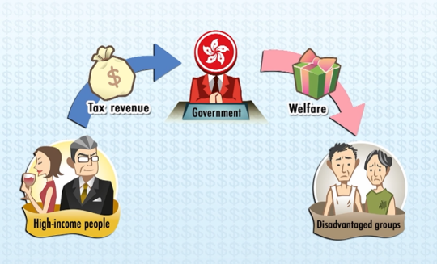

  - To promote economic development
With tax revenue, the government can have sufficient funds to spend on infrastructure, education, transport, etc. to develop social infrastructure and enhance the quality of human resources. Government spending and policy priorities facilitate the economic development of Hong Kong and enhance its competitiveness in terms of its focusing on the development of industries with advantages, including the traditional four pillar industries (i.e, financial services, tourism, trading and logistics, and professional services and other producer services), and other priority industries (e.g., education services, medical services, testing and certification services, environmental industries, innovation and technology, and cultural and creative industries).

  - To respond to social needs
To respond to social needs (such as poverty alleviation, catering for the housing needs of the public, tackling with an aging population, etc.), the government implements different policies by making use of public resources. The government provides the people with many public services and goods so as to fill the gap of insufficient supply in the market, such as security, fire safety, medical care, education, housing and social welfare. They are heavily subsidised by the government to ensure the availability for the public.

Factors affecting government expenditure
- The principles underlying the Government’s management of public finances as stipulated in the Basic Law:
Articles 107 and 108 of the Basic Law states the Hong Kong Special Administrative Region shall follow the principle of keeping expenditure within the limits of revenues in drawing up its budget, strive to achieve a fiscal balance, avoid deficits, implement a low tax policy and practise an independent taxation system. These requirements provide established guidelines on government revenue and spending that the government has to follow.

- Government revenue and reserves:
The economic environment affects government revenue. When the economic environment is good, the government revenue will also increase and the government may then spend more. Therefore, if the government can increase its revenue, it can increase its expenditure accordingly. When the economic environment is poor, reserves can be used to meet emergency needs where necessary and proper.

- Policy directions:
Government policies have a direct impact on public expenditure. Directions of development for the following year will be formulated in the annual policy address prepared by the Chief Executive. Government expenditure will be allocated in accordance with the policy directionses and in line with the direction of the development of the community. For example, as proposed in the Policy Address 2022, the government will allocate funds for building the new Light Public Housing (LPH). About 30,000 units will be completed in five years, increasing the overall public housing supply by about 25%. This helps relieve the pressure of families living in unpleasant conditions and those waiting for public rental housing for a long time. So policy directions are another important factor affecting government expenditure.
Note: Government revenue and reserves are limited resources. For example, if the government allocates more resources to education, it may need to cut the budget in other spending areas (such as medical care), or its reserves will decrease.

Appendix 2
Know More: Approval of the Budget rests
with the Legislative Council

Why does the Financial Secretary(“FS”) deliver the annual Budget Speech, usually in February each year, at a Legislative Council meeting?

According to Article 73 of the Basic Law, the Legislative Council of the Hong Kong Special Administrative Region (LegCo) shall exercise the powers and functions to examine and approve budgets introduced by the government and to approve taxation and public expenditure. So FS has to report to the LegCo on the Budget.

In the Budget Speech, FS outlines the Government’s budgetary proposals of the coming financial year (i.e. 1 April of the year to 31 March of the coming year) and introduces the Appropriation Bill. The Budget is then referred by the President of the Legislative Council ("the President") to the Finance Committee ("FC") for detailed examination.

Upon the debate on the Second Reading, LegCo Members may speak on the financial and economic state of Hong Kong and the general principles of Government policy and administration as indicated by the Appropriation Bill and the Estimates of Expenditure. To enable all Members to have the chance to speak on the Bill, the Council hold its meeting on two consecutive days. The Government responds to Members’ speeches at the following Council meeting. The Council will then go through the Second and Third Reading stages*.

When the LegCo approves the Budget, the Chief Executive will act according to the Article 48(3) of the Basic Law, “To sign budgets passed by the Legislative Council and report the budgets and final accounts to the Central People's Government for the record”.

Since the Budget involves public expenditure and has a long term impact, the government will conduct consultations through different channels before the Budget is formulated and proposed. Together with the discussions of the Council Members, the government can listen to the opinions of the public and different sectors of society so that the Budget can be formulated appropriately.

In sum, the LegCo is responsible for examining and approving the Budget as well as approving the taxation and public expenditure. This allows representatives of the public to monitor how the government uses various financial resources and reduce the abuse and misallocation of resources.

*For details, please refer to the Legislative Council in Brief No.8, “How does the Legislative Council approval public expenditure” (https://www.legco.gov.hk/education/files/english/Factsheet/Factsheet8.pdf)

Appendix 3
Know More: Can the Legislative Council refuse
to pass a budget proposed by the government?

If the Legislative Council refuses to pass a budget introduced by the government, the Basic Law states the following procedures:
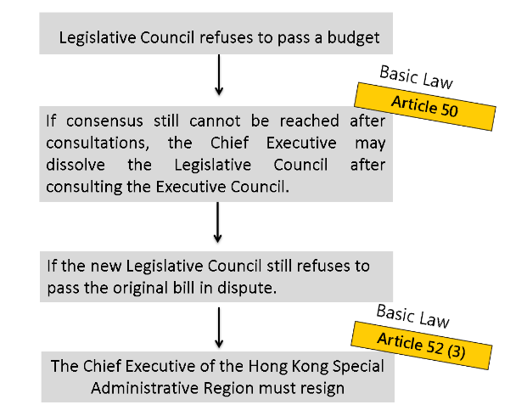
During the period when the Legislative Council refuses to approve the budget proposed by the government, will the government be suspended without funds?
The services provided by the government will not be completely suspended due to lack of funding, because:
According to Article 51 of the Basic Law, the Chief Executive may apply to the Legislative Council for provisional appropriations. If appropriation of public funds cannot be approved because the Legislative Council has already been dissolved, the Chief Executive may, prior to the election of the new Legislative Council, approve provisional short-term appropriations according to the level of expenditure of the previous fiscal year.

Source: https://www.legco.gov.hk/general/english/procedur/companion/chapter_12/chapter_12.html#12.4

Appendix 4

Know More: What are the economic impacts
of the government fiscal policy?
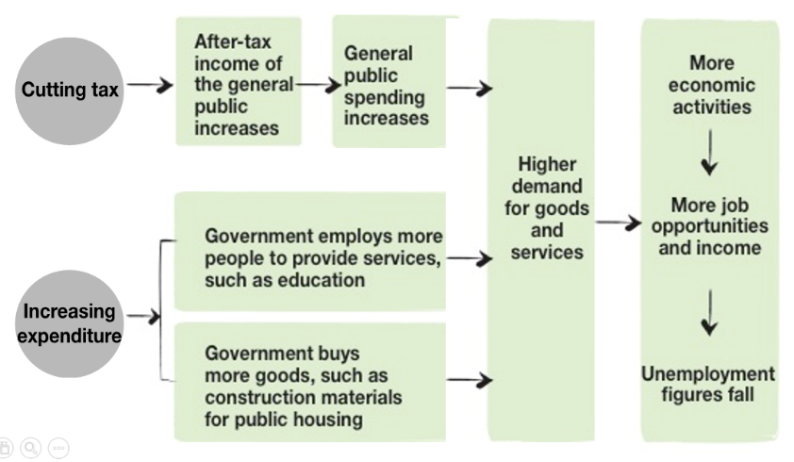
Government may stimulate economic growth through fiscal policy. The following diagram shows government stimulate economic growth through reducing tax or increasing expenditure.
Think about it:
Why do some countries still increase government expenditure and implement deficit budgets during economic downturns?

Worksheet 6
Case Study: Anti-epidemic measures
Source 1: The 2020-21 Budget Speech (extract)
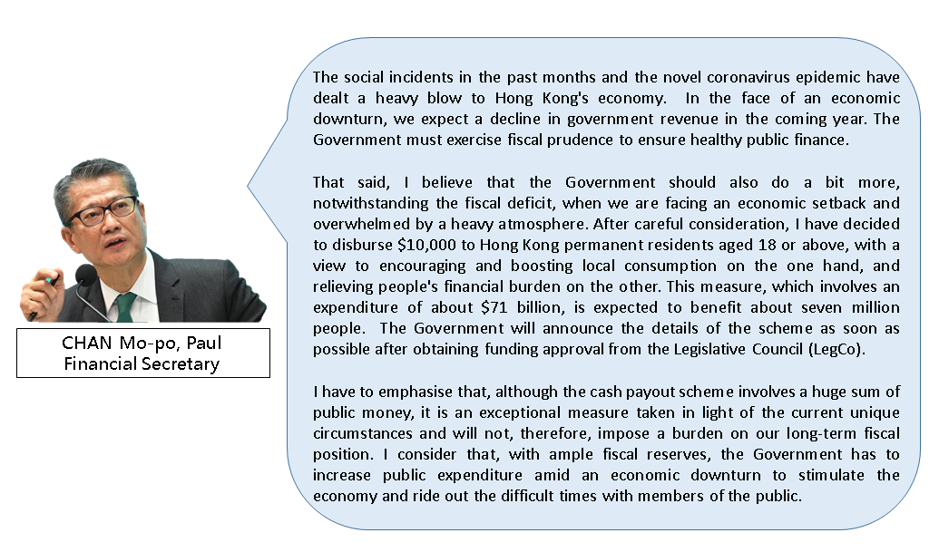
Source: The 2020-21 Budget Speech

Source 2:
2019-20 and 2020-21 Government estimated expenditure
By policy group | 2019-20 | 2020-21
Economic | $38.5 billion | $120.9 billion
Social welfare | $97.2 billion | $115.0 billion
Health | $88.6 billion | $97.7 billion
Others  (including community and external affairs, environment and food, security infrastructure and education) | $383.5 billion | $397.5 billion
Total government expenditure | $607.8 billion | $731.1 billion

2019-20 and 2020-21 Government estimated revenue
Item | 2019-20 | 2020-21
Salaries tax and Profits tax | $226.2 billion | $190.8 billion
Land premium and Stamp duty | $219.0 billion | $193.0 billion
Investment income | $47.9 billion | $57.0 billion
Others | $133.0 billion | $131.7 billion
Total government revenue | $626.1 billion | $572.5 billion

Sources:
2019-20 Budget: https://www.budget.gov.hk/2019/chi/io.html
2020-21 Budget: https://www.budget.gov.hk/2020/chi/io.html

Source 3: 2020-21 Budget (extract)
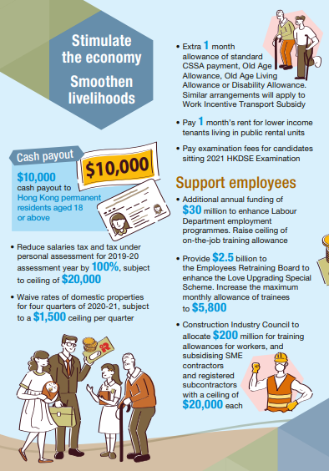
Source: 2020-21 Budget: https://www.budget.gov.hk/2020/eng/pdf/Budget2020_eng.pdf

Answer the following questions based on Sources 1-3 above.
- In 2020-21, the estimated total government expenditure increases substantially compared with the previous year, while the estimated total revenue falls sharply. Explain why this happened based on what you know.
Due to the months-long social incidents in 2019 and the on-going COVID-19
pandemic, the economy has been severely hit (resulting in less corporate income
and more unemployment). The government planned to increase its expenditure
in order to support business operations, reduce the burden on residents and
stimulate consumption, resulting in an increase in estimated total government
expenditure.
At the same time, with the decline in corporate profits and employees’ income,
it is expected that government revenue from profits tax and salaries tax would
also decline, resulting in a decrease in estimated total revenue.

- What happens to government finances if it has less revenue than expenditure? What is the impact on government performance in future?
The government runs a fiscal deficit if its revenue is less than its expenditure.
Then it needs to use fiscal reserves accumulate d in the past to meet the.
Expenditure. This will consume government’s fiscal reserves and weaken its
ability to address emergency financial needs with its fiscal reserves in the future.

- According to Source 3, as reflected in the 2020-21 Budget, how does the government adjust its expenditure and revenue to cope with the changes in the economic environment? Here are some relief measures against the COVID-19 pandemic. Do they have an impact on government expenditure or revenue? Please mark a “✓” where appropriate.
Measures | Increase expenditure | Reduce revenue
$10,000 cash payout to Hong Kong permanent residents aged 18 or above | ✓
Extra 1 month allowance of standard CSSA payment, Old Age Allowance, Old Age Living Allowance or Disability Allowance, as well as Work Incentive Transport Subsidy | ✓
Paying examination fees for candidates sitting 2021 HKDSE Examination | ✓
Reducing salaries tax and tax under personal assessment for 2019/20 assessment year by 100%, subject to a ceiling of $20,000 |  | ✓
Waiving rates of domestic properties for four quarters of 2020/21, subject to a $1,500 ceiling per quarter |  | ✓

- If you were the Financial Secretary, what strategy would you adopt to deal with the economic situation mentioned in the sources? Why?
To disburse consumption vouchers to residents so as to stimulate local consumption
and accelerate economic recovery.
(Other reasonable answers are acceptable)
Question 4 allows teachers to understand students’ thoughts. It also provides an opportunity for students to think about the principles of prioritising public finance and reasons behind it, such as which industries / people should be assisted first. Teachers can guide students to assess the appropriateness of strategies based on the actual situation.

Extended Worksheet: Unemployed Chef Wong
Source 4: Mr Wong becomes unemployed
Due to the COVID-19 pandemic, Hong Kong’s economy has fallen into recession, and the number of unemployed persons has continued to increase. Mr Wong was also greatly affected.
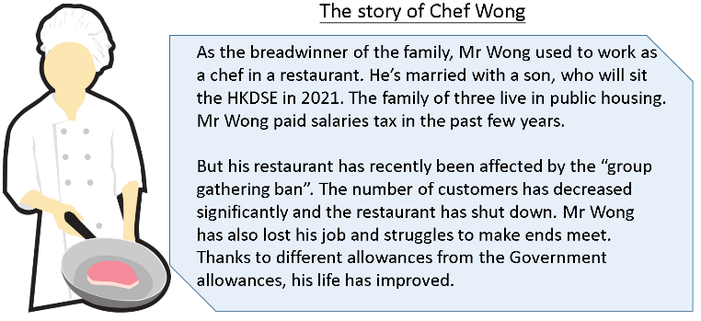
* The Prevention and Control of Disease (Prohibition on Group Gathering) Regulation, commonly called the “group gathering ban”, mainly includes the limit on the number of people allowed in group gatherings in public places.

- Based on Sources 3 and 4, Mr Wong and his family can benefit from which anti-epidemic measures?
- $10,000 cash payout to Hong Kong permanent residents aged 18 or above
- Paying examination fees for candidates sitting 2021 HKDSE Examination
- Reducing salaries tax and tax under personal assessment for 2019/20
assessment year by 100%, subject to a ceiling of $20,000
- Paying 1 month’s rent for lower income tenants living in public rental units

- Based on Mr Wong’s example and your knowledge, explain why the government provides allowances to its residents.
The COVID-19 pandemic severely hits the economy. The livelihoods of many
people are greatly affected due to unemployment or wage cuts. The allowances
provide the public with more financial resources and relieve their economic
pressure. After receiving the allowances, consumers will have more money
to spend, which helps stimulate personal consumption expenditure, increase
the demand for goods and services, and help improve the economy.
Module 2.3：Public Finance of Hong Kong
(Lessons 7 and 8)
Learning and Teaching Materials

Worksheet 7: Our responsibilities and rights
Read the following people’s profiles and answer the questions.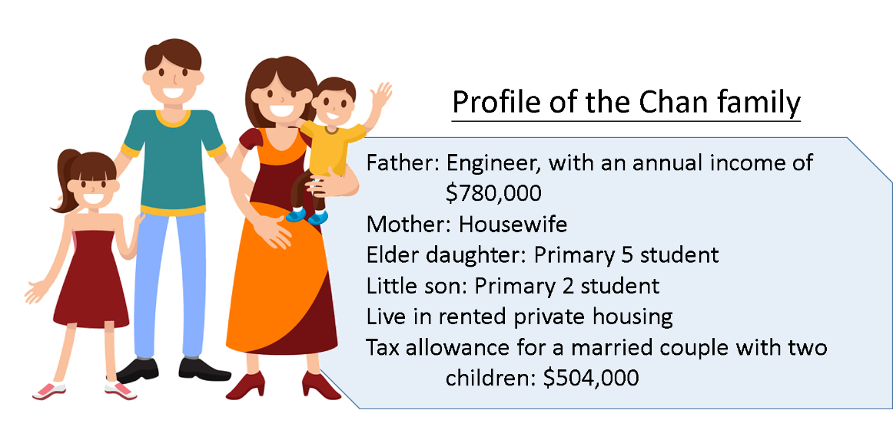
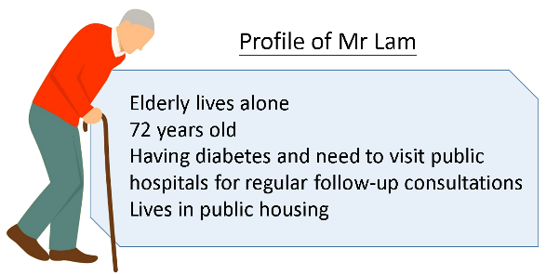
Values education: Guide students to reflect on equality and the common good of society. Ask students to think about how they can contribute to the development of society as a whole, and care for the needy in the community.
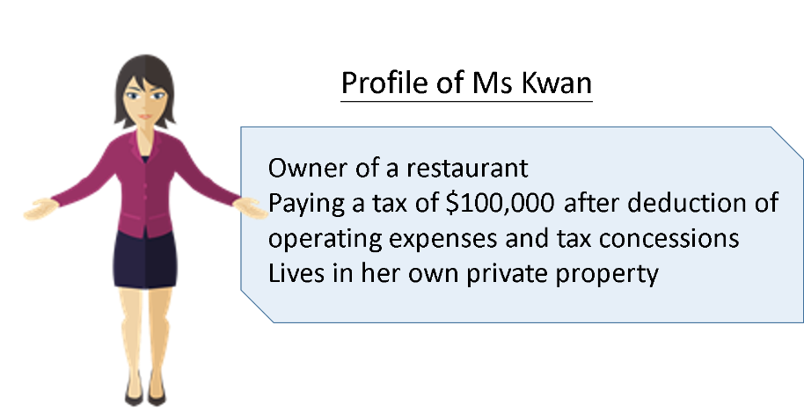
- Based on what you have learned:
- what taxes are these people liable to pay? (name the tax(es), if any) (Hint: see Worksheet 1: What are the sources of government revenue?);
- what government services do they use? (name two of the services, if any) (Hint: see Worksheet 2: What are the government expenditures in Hong Kong?)
Teaching tips: In many cases, members of the community have different opinions on the Government’s revenue and expenditure policies. To become rational and responsible citizens, students should develop the ability to analyse the arguments of different stakeholders on related policies.
 | Tax liability | Social services used (any two)
The Chan Family | - Salaries tax | - Education  - Security  - Support service  - Infrastructure
Mr Lam | - / | - Housing  - Social welfare (OALA)  - Health  - Security  - Support services  - Infrastructure
Ms Kwan | - Profits tax  - Rates | - Security  - Support  - Infrastructure

- What aspirations do you think they might have towards the Budget? Put a to indicate the choices.
 | Rent Waiver Or Subsidy For Public Housing | Tax Refund | More Home Ownership Scheme Flats | Lowering The Salaries Tax Rate | Rates And Government Rent Concessions
The Chan family
Mr Lam
Ms Kwan

- Why should Hong Kong citizens pay taxes? Explain from the perspective of civil rights and responsibilities.
As members of society, we have the right to enjoy social services, such as
receiving education and medical services. At the same time, we should shoulder
the responsibility of paying taxes if we can. We should contribute to society by
paying taxes to the government, so that the government can continue to operate
and provide social services for Hong Kong residents.

- The government formulates the taxation system based on different principles, including “who earns more pays more taxes”. Do you agree with this principle?
For example:
FOR: Taxation funds the government’s provision of goods and services for
residents. When people with higher incomes need to pay more taxes, the
government can reallocate the funds to those who earn less. It helps narrow the
gap between the rich and the poor.
AGAINST: Every Hong Kong resident is a member of society and they have
the same right to enjoy social services. So they should bear the same responsibility
to pay taxes

- Based on the answer to Question 4, explain what the government can do in taxation to narrow the wealth gap.
The government can impose more tax types and/or higher rates on higher-income
group(s), so that wealth in society can be reallocated through taxation. On the other
hand, the Government can use tax income to provide lower-income families with
financial assistance and some necessary public services (such as housing, medical
care, education, etc.). It helps narrow the gap between the rich and the poor and
enables dignity.
(Other reasonable answers)

Relationship between the government and Hong Kong citizens in public finance
As a member of society, Hong Kong citizens have the right to social welfare in accordance with law on the one hand, and they also have the responsibility to pay taxes.

The right to social welfare in accordance with law
Hong Kong citizens have the right to social welfare in accordance with law, and enjoy various social services provided by the government, for example, 15-year free education, public medical services, cultural and recreational facilities, etc., in accordance with law. These social services are basically provided free of charge or below cost to ensure the basic needs of Hong Kong citizens. In that way, no one would be prevented, through lack of means, from obtaining fundamentalsocial services.

Tax liability
Tax filing and payment on time are the responsibility of Hong Kong citizens. Failing to pay taxes on time or in full will be subject to surcharges and legal liabilities. Taxation is the main source of government revenue. Since we have the right to use government services, we should bear the responsibility of paying taxes, so that the government has sufficient funds to provide related services. Besides, as responsible Hong Kong citizens, we should build the community together and take responsibility for the development of society as a whole. We should help those in need in the community in line with civic responsibility and the spirit of mutual assistance and care.
Values education: Remind students that rights and responsibilities are inter-related, and that paying taxes is a civic responsibility.

Lead-in Activity 3: “Do you know our needs, Mr. Financial Secretary?”
Every year, the Financial Secretary collects opinions from the public on the Budget for the following year. Government expenditure has an important impact on people’s livelihood and the overall economy. What do people from different strata of society expect from the Budget?
The labour market shows further sharp deterioration as the COVID-19 pandemic continues to affect a wide range of economic activities. The unemployment rate soared by 1.0 percentage point to 5.2% in February - April 2020, the highest in the decade. The government should use resources effectively to improve people’s livelihood, create diversified jobs, and provide relief measures for vulnerable groups.

In what areas do you think the government can increase its expenditure to respond to the above issues?
Labour and social welfare
Property prices are rocket high in Hong Kong. Even many professionals cannot afford to buy a flat. The Government does not provide adequate welfare and social security, either. We are really under great pressure!

In what areas do you think the government can increase its expenditure to respond to the above issues?
Housing and providing middle-class home purchase loans

Worksheet 8: Please listen to us, Mr Financial Secretary
Every year the government conducts public consultation on the Budget. Interview two friends or family members. Ask them what they would like to tell the Financial Secretary and why. Do you think their suggestions are feasible? From the perspective of the overall well-being of society, should their suggestions be implemented? (You can find data and information of related items to support your argument)
You may refer to the website of the 2022-2023 Budget: https://www.budget.gov.hk/2022/eng/io.html
Name/  nickname | What he/she tells the Financial Secretary? | Why? | Are the suggestions feasible? From the perspective of the overall well-being of society, should they be implemented?
My opinion

Teaching tips: Members of the community have different opinions on the Government’s revenue and expenditure policies. To become rational and responsible Hong Kong residents, students should develop the ability to analyse the arguments of different stakeholders on related policies. Upon understanding the needs of different people in society, they should know how to make use of appropriate channels to express their views on the government Budget. Students can then cultivate a concern for social affairs, as well as attempt to analyse government’s public finance policies from the perspective of the overall well-being of society

Reference
Census and Statistics Department
https://www.censtatd.gov.hk/en/

Education MultiMedia
https://emm.edcity.hk/

Websites of the Budget
The 2022-23 Budget: https://www.budget.gov.hk/2022/eng/index.html
The 2021-22 Budget: https://www.budget.gov.hk/2021/eng/index.html
The 2020-21 Budget: https://www.budget.gov.hk/2020/eng/index.html
The 2019-20 Budget: https://www.budget.gov.hk/2019/eng/index.html

KPMG Corporate Tax Rate 2010-2020
https://home.kpmg/xx/en/home/services/tax/tax-tools-and-resources/tax-rates-online/corporate-tax-rates-table.html

KPMG Individual Tax Rate 2010-2020
Individual income tax rates table - KPMG Global (home.kpmg)

中華人民共和國稅收概述2021（普華永道）
https://www.pwccn.com/zh/tax/people-republic-of-china-tax-facts-2021.pdf

Article 31 of the Constitution stipulates that “The state may establish special administrative regions when necessary. The systems instituted in special administrative regions shall, in light of specific circumstances, be prescribed by laws enacted by the National People’s Congress.”
Item 14 of Article 62 of the Constitution stipulates that the National People’s Congress shall decide on “the establishment of special administrative regions and the system to be instituted there”.

